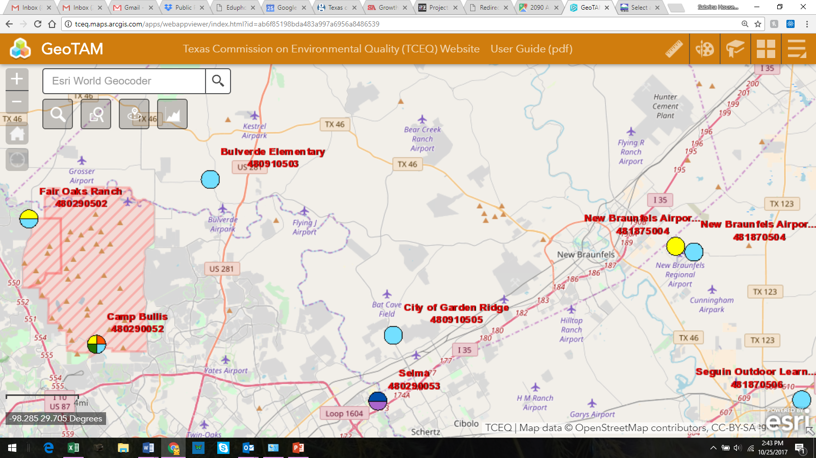
Dean Word & Capital Aggregate
Brauntex & Cemex
Vulcan Materials
11 miles/ozone only
35 miles. ozone/meteorological/air toxins VOC/nitrogen
Anderson Columbia x 2
Hanson Materials
Asphalt Inc Quarry
13 miles/PM 2.5 & PM 10
Martin Marietta
21 miles/ozone & meteorological
Locations of plant operations not exact. Only to show total number. Mileage calculated to Vulcan Materials @ Hwy 46 and Loop 3009 only
13 miles/0zone only
28 miles/ozone & meteorological
13 miles/ozone only
13 miles/ozone only
13 miles/ozone only
13 miles/ozone only
13 miles/ozone only
13 miles/ozone only
11 miles/ozone only
28 miles/ozone only
13 miles/ozone only
11 miles/ozone only
Hanson Materials

