December 17, 2018

Member Organizations
Alamo, Austin, and Lone Star chapters of the Sierra Club
Aquifer Guardians in Urban Areas
Bexar Audubon Society
Bexar Green Party
Boerne Together
Cibolo Nature Center
Citizens Allied for Smart Expansion
Citizens for the Protection of Cibolo Creek
Comal County Conservation Alliance
Environment Texas
First Universalist Unitarian Church of San Antonio
Friends of Canyon Lake
Friends of Dry Comal Creek
Friends of Government Canyon
Fuerza Unida
Green Party of Austin
Headwaters at Incarnate Word
Helotes Heritage Association
Helotes Nature Center
Hill Country Planning Association
Green Society of UTSA
Guadalupe River Road Alliance
Guardians of Lick Creek
Kendall County Well Owners Association
Kinney County Ground Zero
Leon Springs Business Association
Medina County Environmental Action Association
Native Plant Society of Texas – SA
Northwest Interstate Coalition of Neighborhoods
Preserve Castroville
Preserve Lake Dunlop Association
San Antonio Audubon Society
San Antonio Conservation Society
San Geronimo Nature Center
San Geronimo Valley Alliance
San Marcos Greenbelt Alliance
San Marcos River Foundation
Save Barton Creek Association
Save Our Springs Alliance
Scenic Loop/Boerne Stage Alliance
Securing a Future Environment
SEED Coalition
Solar San Antonio
Sisters of the Divine Providence
Travis County Green Party
West Texas Springs Alliance
Water Aid – Texas State University
Wildlife Rescue & Rehabilitation
Wimberley Valley Watershed Association
PO Box 15618
San Antonio, Texas 78212
(210) 320-6294
PO Box 15618
San Antonio, Texas 78212
(210) 320-6294
www.AquiferAlliance.org

Bridget Bohac, Chief Clerk
Texas Commission on Environmental Quality
Office of the Chief Clerk, MC 105
P.O. Box 13087
Austin, Texas 78711-3087

Submitted electronically at www.tceq.texas.gov/about/comments.html

Re: Comments and Hearing Request Regarding Application of DTB Investments, L.P. for TPDES Permit No. WQ0015092001

Please accept the attached comments on behalf of the fifty-two member groups of the Greater Edwards Aquifer Alliance.

1. Background. DTB Investments, L.P., 28615 Interstate Highway 10 West, Boerne, Texas 78006, has applied to the TCEQ to amend Texas Land Application Permit No. WQ0015092001 to authorize a change in the method of effluent disposal from surface irrigation to discharge at a volume not to exceed a daily average flow of 300,000 gallons per day under a Texas Pollutant Discharge Elimination System Permit (EPA I.D. No. TX0138304). The domestic wastewater treatment facility is located 0.42 mile west of the intersection of East Ammann Road and Persimmon Road and 0.13 mile north of East Ammann Road. The discharge route is from the plant site to an unnamed tributary; thence to Indian Creek; thence to Upper Cibolo Creek in Segment No. 1908 of the San Antonio River Basin.

2. Greater Edwards Aquifer Alliance (GEAA). GEAA submits the following comments and requests a public meeting and contested case hearing regarding this permit application. GEAA is a 501(c)(3) nonprofit organization that promotes effective broad-based advocacy for protection and preservation of the Edwards Aquifer, its springs, watersheds, and the Texas Hill Country that sustains it. GEAA accomplishes this by producing and distributing educational materials that assist public and private sector decision-makers to take actions to protect and sustain the quality and quantity of Edwards Aquifer flows. We also expand and aid the coordination of existing public interest for sustainable water and land use practices in the Greater Edwards Aquifer region.

GEAA has multiple members who would be adversely affected by the proposed application of DTB Investments, L.P. GEAA’s members’ ability
to enjoy Indian Creek, Cibolo Creek, the middle San Antonio River, and the surrounding area would be harmed by TCEQ approval of the application. Accordingly, GEAA urges DTB Investments, L.P utilize a “One Water” approach for their wastewater treatment system, incorporating beneficial reuse of effluent, thereby eliminating the need to discharge effluent into Indian Creek. In the event DTB Investments, L.P is unable to reuse all of the wastewater generated, it is GEAA’s recommendation that the remaining amounts be land applied, with DTB Investments, L.P purchasing the necessary land for such and obtaining the requisite TLAP permit from TCEQ.

3. Comments on the Application. As noted in the Receipt Of Application And Intent To Obtain Water Quality Permit, the proposed discharge route is from the wastewater plant site via pipe to a dry tributary; thence to Indian Creek; thence to Cibolo Creek; thence to the San Antonio River. There are several areas of concern with the current application:

a) Impact on the Edwards Aquifer. The proposed effluent discharge point is less than three miles from the Edwards Aquifer recharge zone. The three-mile path would consist mostly of effluent, as Indian Creek and its tributary are dry most of the time. The effluent would then empty into Cibolo Creek, which recharges the Edwards Aquifer. According to the USGS, this recharge section of Cibolo Creek was dry more than 95% of the time over the past five years.¹ Therefore, introducing a stream of effluent would create a direct undiluted path from the wastewater treatment plant directly into the Edwards Aquifer, which provides drinking water for 1.7 million Texans. This effluent would have high levels of nitrogen and phosphorous and would also contain Contaminants of Emerging Concern (CECs) including pharmaceuticals, surfactants, and other pollutants. There are numerous human health risks associated with the contamination of the Edwards Aquifer with wastewater plant effluent.

The point at which the effluent would enter the Edwards Aquifer is the confluence of Indian Creek and Cibolo Creek (recharge zone), less than three miles from the proposed effluent outfall. According to the Texas Water Development Board, there are 21 wells within a one-mile radius of this recharge zone area; 14 of these wells are public supply wells which provide drinking water to the City of Bulverde and the surrounding area (see fig 1 on the next page). Therefore, contamination of local groundwater and drinking water is a primary concern with the proposed permit.

b) Impacts on Cibolo Creek. Cibolo Creek runs approximately 96 miles from its source west of Boerne TX to its confluence with the San Antonio River. The point at which the effluent would enter Cibolo Creek under this permit is approximately 25 miles downstream from the Cibolo Creek headwaters, so most of Cibolo Creek would be impacted by this permit. The next 20 miles of Cibolo Creek below the effluent outfall point consists of alternating reaches of dry limestone creek and often lengthy pools of clear water which are home to fish and other aquatic life. These pools are small local ecosystems, supporting surrounding wildlife and vegetation. The proposed permit would not only impact the Edwards Aquifer as described in section a) above, but these pools would change from clear, pristine life-supporting water bodies to algae-covered, low-oxygen nutrient-heavy ponds. Fish and other aquatic life that reside in these pools would not be able to escape to more oxygenated water and would likely die off.

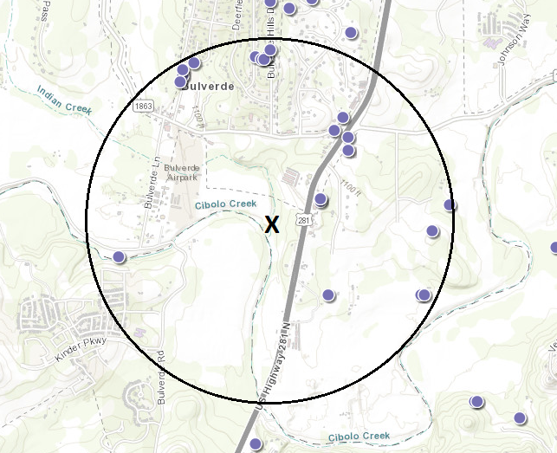
Fig 1: Location of 21 wells that lie within a one mile radius of the point where the proposed effluent recharges the Edwards Aquifer²

c) Cumulative Impacts. There are several other Cibolo Creek-area wastewater permits that have either been approved or are currently in the TCEQ permit approval process. As hundreds of thousands of gallons per day of effluent becomes millions of gallons per day, with each new permit, the cumulative impacts of wastewater discharges become greater and are felt further and further downstream. To date, no studies or analysis has been done by any entity regarding the cumulative impacts of multiple effluent outflows on the Cibolo Creek watershed, which is of great concern to the Greater Edwards Aquifer Alliance, as our primary mission is protection of the aquifer and its contributing waterways.

d) Accidental Spills. Due to the close proximity of the outfall point to the Edwards Aquifer recharge zone, an accidental spill or discharge of raw sewage or partially-treated sewage from the proposed wastewater plant would prove catastrophic, given the local conditions described above. But even under normal operation, following standard procedures and safeguards for wastewater treatment plants, the local impacts would still be severe, not only to Texas Hill Country wildlife, but to the health of those Texas residents who live near Cibolo Creek.

The TCEQ has previously stated that in evaluating wastewater permits, they consider the baseline conditions in the receiving stream, the physical and hydrological characteristics of the stream, water body uses, and the associated water quality standards that protect those uses. None of these criteria would indicate that the proposed wastewater plan is suitable for this area. Accordingly, GEAA encourages the TCEQ to reject the proposed permit.

Sincerely,
Annalisa Peace
Executive Director

¹ USGC stream discharge data, 2013-2018 for USGS station 08184050 Cibolo Creek https://waterdata.usgs.gov/nwis/uv?site_no=08184050

² Texas Water Development Board (TWDB) groundwater/well viewer https://www2.twdb.texas.gov/apps/waterdatainteractive/groundwaterdataviewer

