Honey Creek Ranch Development
Initial Developer Meeting at Honey Creek Ranch 8/31/18
TCEQ Community Meeting in Bulverde 8/20/19
Prepared initially by Joel Dunnington 9-5-18 and updated after the TCEQ Meeting on 8/30/19
Final 9-4-19
jsdunnington@gvtv.com
The proposed Honey Creek Ranch Subdivision will be built at the upper portion of the Honey Creek watershed. Honey Creek runs through the 2,293.7 acre Honey Creek State Natural Area and into the Guadalupe River. Honey Creek normally gets it flow from the Honey Creek Cave and a few small springs. Honey Creek is truly one of the most pristine, clear and pure steams remaining in Texas. That is why it is preserved as the Honey Creek State Natural Area.

The initial meeting at Honey Creek Ranch started about 9:15 am on 8/31/18. Kelly M. Leach, a real estate consultant representing Silesia Properties, was there with four of his employees (consultants?). There were Texas Parks and Wildlife Department (TPWD) staff from Guadalupe River State Park. There were about five more TPWD staff from the Austin office. This included the TPWD Water Quality Program Leader, Anne Harrison. There were four people from the Comal Trinity Groundwater Conservation District. There was one person from the Guadalupe River Association. One person from the Greater Edwards Aquifer Alliance. The District staffers for State Representative Kyle Biedermann and State Senator Donna Campbell were present. And I was representing the Comal County Conservation Alliance.

The Honey Creek Ranch WWTP regulated entity number is RN110389046. The Honey Creek Ranch Development company name is Silesia Properties, LP, and the address is 24114 Blanco Road, San Antonio, Texas 78260. The Honey Creek Ranch address is 26226 State Highway 46 West, in Comal County, Texas 78070. Mr. Leach is also a partner in the Ventana Development on the other side of Highway 46 from Honey Creek Ranch. Honey Creek Ranch is owned by Ronald and Terry Urbanczyk and their daughter, Kristin Urbanczyk Aljoe, according to county land records. The Urbanczyks also run Urban Concrete Contractors in San Antonio. State records show the managers of Silesia Properties are Terry G. Urbanczyk, Ronald D. Urbanczyk, and Kristin Urbanczyk Aljoe.

Silesia Properties, LP is a Texas Domestic Limited Partnership filed in August 12, 2010. The registered agent on file is Kristin Aljoe and is located at 313 Frey Street, Boerne TX. And the company’s principal address is 24114 Blanco Road, San Antonio, TX. 78258. The company has two principals on record. The principals are U Bar 5, LLC from San Antonio and U-5 Gp from San Antonio, TX.

The Honey Creek Ranch Development will have approximately 2,396 homes. The lot size is currently listed as 45 feet X 110 feet. That averages out to about 8 houses per acre. The plans are not exact at this time. The development is estimated to cost $60,000,000. About 100 acres of the 592 acres will be parks in the central portion of the subdivision. There is a dry creek running through the center of the park. The domestic wastewater treatment facility will be located at 26226 State Highway 46 West, Spring Branch, in Comal County, Texas 78070. The discharge of treated sewage effluent will be on the southern part of the dry creek and the first mile of any effluent discharge will be through the subdivision. That dry creek goes into Honey Creek and the Honey Creek State Natural Area before there is water entering the creek from the Honey Creek Cave. This development is in the ETJ of Bulverde. A development plan is on file with Bulverde, but Bulverde has not approved it yet.

Silesia has applied for a Texas Commission on Environmental Quality (TCEQ) Texas Pollutant Discharge Elimination System (TPDES) Permit to discharge 500,000 gallons of treated sewage effluent into Honey Creek daily. The TPDES Permit number is WQ0015688001. According to the permit application, additional information can be obtained from Dr. David Graham, P.E., South Texas Wastewater Treatment.

Silesia claims that the majority of treated sewage effluent will be used as graywater for irrigation of the park areas. They claim that almost all of the projected effluent will be used up with irrigation. However, until the subdivision is built out, there will not be enough effluent water produced to irrigate the landscaping. So it will be supplemented with water from the grandfathered Trinity Aquifer wells owned by the Texas Water Supply Company. The water for all of the houses will be from the same source. Apparently the Ventana subdivision across the street also gets its water from the Texas Water Supply Company. This water comes from the Middle Trinity Group Aquifer from grandfathered wells in northern Bexar County that are not under any regulatory authority. The water will be piped by the South Comal Water District which is now building the pipeline from Bexar County.

The houses will not have rainwater collection systems, even though the project is billed as a green community. The density will be approximately 8 houses per acre, not accounting for the streets and landscaping. There will be clay lined retention ponds for storm water runoff. They say they will store water onsite to be used for irrigation and not released except in extenuating circumstances of a flood. The developer stated that the retention ponds and infrastructure will comply with the new Atlas 14 NWS Point Precipitation frequency estimates which exceed the current rainfall estimates. This should manage flooding, hopefully!

Initially the developer said there will be a MUD District to manage the water treatment and maybe the potable water. The proposed subdivision is in the ETJ of Bulverde. The City of Bulverde approved the creation of a MUD with some restrictions. Silesia apparently tried to introduce and pass a law in the Texas legislature to create a special MUD District to go around the Bulverde restrictions. The City of Bulverde opposed the attempt to pass a state MUD law for Silesia. The state law did not pass in the 2019 session. In May, Bulverde City Council approved an application for a municipal utility district, a special tax district to fund wastewater infrastructure at the site. At the August 2019 TCEQ Public Hearing Mr. Leach said there would not be a MUD. Apparently Bulverde did not want to put sewage lines out to the Honey Creek Ranch. Silesia has not chosen what type of wastewater treatment plant they will utilize. Apparently Silesia has agreed to a 2,000,000 gallon storage facility on site, but the permit has not been updated to include this.

The developer still has to file a Section 210 Beneficial Reuse Permit and a Contributing Zone Plan. From my reading, developers have been known to say they will apply for a 210 Beneficial Reuse Permit, but do not apply after they have successfully obtained a wastewater discharge permit from TCEQ.

It was mentioned at the initial meeting that one of the developer’s other Hill Country developments (Singing Hills) has had 2 sewage effluent releases and the development is not half finished. A release here would flow into the pristine Honey Creek and into the Honey Creek State Natural Area, which abuts the proposed development. There are numerous karst features and caves in the Honey Creek watershed. From testimony at the Public Hearing and submitted written testimony, here are faults along Honey Creek where water can flow back into the aquifer. Water from the Honey Creek Cave supplies most of the usual flow to Honey Creek. Honey Creek Cave is the longest cave in Texas. 21.5 miles of passages has been mapped up to this time. The known entrance to Honey Creek Cave is on private property adjacent to the proposed development and Honey Creek State Natural Area. As of now there is no known extension of the cave under the Honey Creek Ranch property. However testimony indicated there is an underground stream from that direction, but this area of the cave cannot be explored due to the water. Testimony at the Public Hearing suggested the cave may have connections with the Edwards Aquifer. So any high flow release from the treated effluent might flow back into the cave and then the aquifer. Other testimony stated that there are threatened and special species in the cave and in Honey Creek. There are species that are both in the cave habitat and the stream habitat that need to be further studied. There is one species that may be put forward for listing on the Endangered Species List.

Since there may be an Edwards Aquifer connection through the cave and/or the faults, this may fall under the jurisdiction of the Edwards Aquifer Authority. Apparently the state never followed-up on the study showing these possible connections in the last 24 years. It was suggested that state further study these faults and connections. An effluent release is of concern, but there is another concern. With 2,396 house using pesticides, herbicides and fertilizers on their lawns and the oil and gas runoff from the streets; during floods these contaminants could also contaminate Honey Creek and possibly the Honey Creek Cave. There are supposed to be retention ponds, but will they prevent all flooding over the ponds and into Honey Creek?

The TCEQ Hydrologist attending the public hearing stated that he only a wastewater discharge modeling of the surface water of the dry tributary and Honey Creek. He did not do any modeling to consider the karst geology, faults, and cave. They also did not model how the effluent or Stormwater runoff would impact on local water wells.
The man problem with an effluent release and/or flooding from the subdivision are the nutrients which will be introduced. Honey Creek is a low nutrient creek. The animals and plants that live in Honey Creek are adapted to these low nutrient levels. When a nutrient load is introduced, eutrophication occurs with algae blooms that decrease the Dissolved Oxygen in the water. This can kill the fish and other animals in the streams. So the levels of nitrogen, phosphorus, oxygen levels in the permit are important. Please see these written responses to the permit application for more extensive discussion of the permit wastewater levels- https://dochub.com/fqd176/ZD3w4b/18-09-07-tpwd-comm-honey-creek-pdf?pg=3

https://dochub.com/fqd176/Pq3LJJ/19-08-20-sos-comments-on-silesia-properties-honey-creek-draft-permit-with-attachm?pg=4
https://aquiferalliance.org/wp-content/uploads/2018/11/Comments-on-Silesia-Properties-TCEQ-wastewater-permit-no.-WQ0015688001-signed-REDUCED-converted.pdf
https://www.linkedin.com/pulse/threat-honey-creek-from-proposed-effluent-discharge-slade/

The Nature Conservancy sold the Honey Creek State Natural Area to the state for preservation in 1985. The State Natural Area is so special, visitors are only allowed onto the property with guided hikes or guided science programs. The surrounding landscape has historically been rural in nature with sparsely populated, single owner ranches, no direct discharges of wastewater, and negligible sources of non-point source pollution. Honey Creek provides habitat to several rare animals and plants, including the Cascade Caverns Salamander (Eurycea latitans) and Comal Blind Salamander (Eurycea tridentifera), which are both listed as state threatened species. The Cascade Caverns salamander is currently under review by the U.S. Fish and Wildlife Service to be listed as a federally endangered species under the Endangered Species Act (GEAA written testimony). Even considering these animals, the TCEQ stated that an Environmental Impact study was not needed since this is a state permit. Thus this land is owned by the citizens of Texas and the “affected parties” should include all citizens not just the adjacent landowners.
At the TCEQ Public Hearing, there were a number of extremely well qualified speakers who made presentations and written testimony against the permit. Hydrologists, geologists, biologists and cavers all testified.

An interesting item I learned was that the TPWD and any other state agency is allowed to comment on a TCEQ permit. But the TPWD will not be considered an affected person on any contested hearing. So even though any effluent discharge would flow through the state land of the Honey Creek State Natural Area, TPWD will not be a party to the contested hearing. The rule is 30 TAC 55.103: "Affected person--A person who has a personal justiciable interest related to a legal right, duty, privilege, power, or economic interest affected by the application. An interest common to members of the general public does not qualify as a personal justiciable interest. The determination of whether a person is affected shall be governed by §55.203 of this title (relating to Determination of Affected Person), or, if applicable under §55.256 of this title (relating to Determination of Affected Person). Notwithstanding any other law, a state agency, except a river authority, may not file a request for a contested case hearing or request for reconsideration, nor may it be considered an affected person or named a party, or otherwise contest of a permit or license on an application received by the commission on or after September 1, 2011 unless the state agency is the applicant."

The TCEQ does not put the preliminary permit approval for the wastewater discharge permits online. You have to go to the Mammen Library in Bulverde to look at them or copy them. Apparently the TCEQ rarely conducts spot checks of wastewater plants. And apparently they notify the plant operators that they are coming to inspect. There are no random, unannounced spot checks.

I have attached some articles and documents below.

Effluent Concentrations in the Preliminary Permit

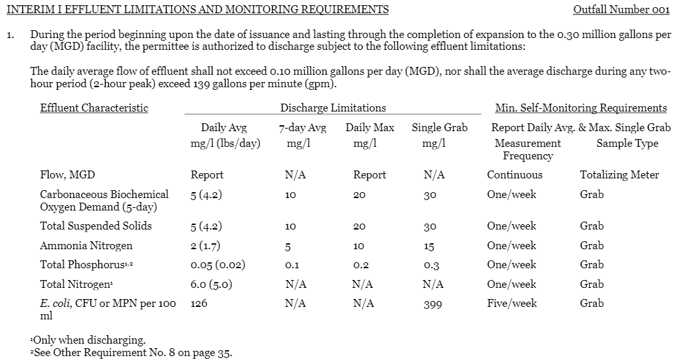
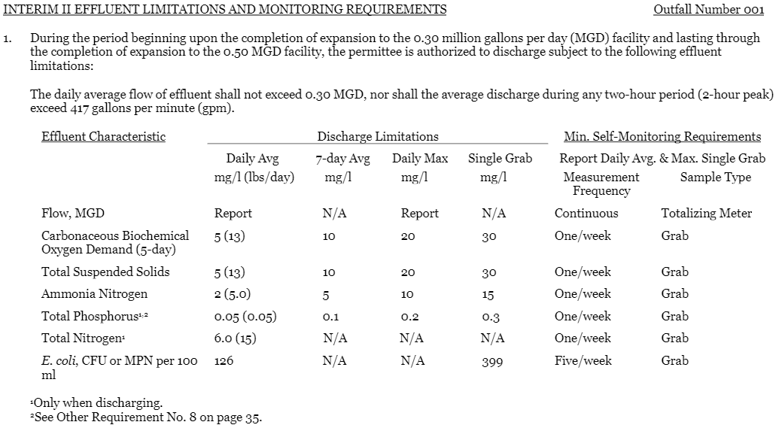
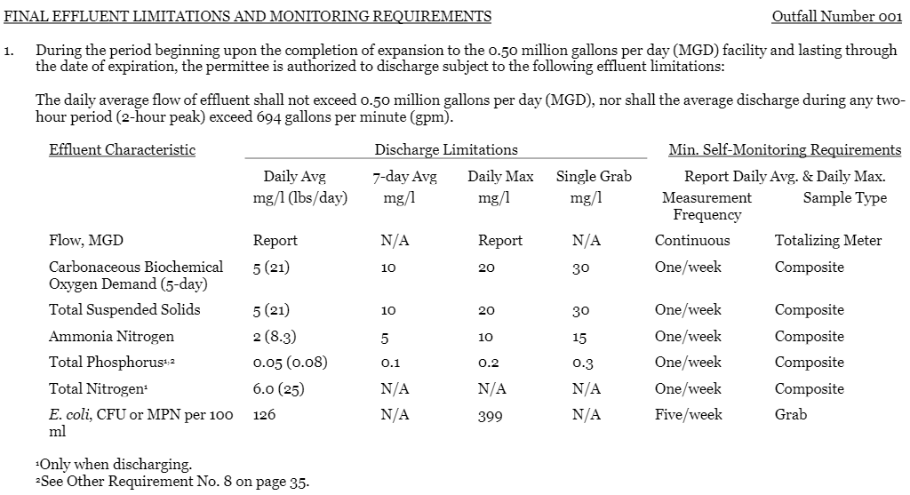
References, Reports and Articles
Silesia Properties and Honey Creek Ranch
https://therivardreport.com/proposed-sewage-treatment-plant-near-honey-creek-will-recycle-water-consultant-says/
https://tceq.maps.arcgis.com/apps/webappviewer/index.html?id=db5bac44afbc468bbddd360f8168250f&marker=-98.5082%2C29.810156&level=12
https://dochub.com/fqd176/lNnX6X/honey-creek-ranch-color-plan-2-pdf?dt=tHsxMAQCUPu-1ptzz6qp
https://aquiferalliance.org/wp-content/uploads/2019/03/BulverdePermitsRevised2.jpg
http://www.bulverdetx.gov/DocumentCenter/View/3449/Phase1B2-Annexation-Area-Map?bidId=
http://www.bulverdetx.gov/DocumentCenter/View/3495/Background-Information-on-Honey-Creek-MUD-and-the-City-Consent-to-Creation-of-the-District?bidId=
http://www.bulverdetx.gov/DocumentCenter/View/3494/City-Council-Resolution-in-Opposition-to-the-Legislative-Creation-of-Honey-Creek-MUD?bidId=
https://dochub.com/fqd176/KoRDkv/2018-honey-creek-application-wq0015688001-reduced-pdf?dt=yC-vZoeN6StqKR9Yiwmx&pg=2

TCEQ
https://www.tceq.texas.gov/agency/decisions/participation/permitting-participation/public-participation-9-1-2015
https://www14.tceq.texas.gov/epic/eCID/
https://nodumpingsewage.org/wp-content/uploads/2018/09/TCEQReviewProcess1.pdf
https://www14.tceq.texas.gov/epic/eNotice/index.cfm?fuseaction=main.PublicNoticeDescResults&requesttimeout=5000&CHK_ITEM_ID=169434312018200
https://www.tceq.texas.gov/assets/public/comm_exec/pm-ph/notices/2019/2019-08-20-silesia-properties-lp-WQ0015688001-combined-nori-napd-pm.pdf
https://www.tceq.texas.gov/agency/decisions/participation/permitting-participation/public-participation-9-1-2015
https://dochub.com/fqd176/KoRDkv/2018-honey-creek-application-wq0015688001-reduced-pdf?pg=4
https://dochub.com/fqd176/Np3nyD/honey-creek-draft-permit-wq0015688001-pdf?pg=19
https://dochub.com/fqd176/ZD3w4b/18-09-07-tpwd-comm-honey-creek-pdf?pg=3
https://aquiferalliance.org/waste-water-discharge/timeline-for-wastewater-permit_geaa/
http://txrules.elaws.us/rule/title30_chapter307_sec.307.5
https://www.tceq.texas.gov/assets/public/permitting/waterquality/standards/docs/2011draft-impprocedures.pdf
Comments to TCEQ
https://www14.tceq.texas.gov/epic/eComment/
https://aquiferalliance.org/wp-content/uploads/2018/11/Comments-on-Silesia-Properties-TCEQ-wastewater-permit-no.-WQ0015688001-signed-REDUCED-converted.pdf
https://aquiferalliance.org/wp-content/uploads/2018/11/Honey-Creek.pdf
https://dochub.com/fqd176/keJWrJ/18-08-13-george-veni-comm-honey-creek-pdf?dt=8exoAptjwQ1dg1VjScpR
https://dochub.com/fqd176/ZD3w4b/18-09-07-tpwd-comm-honey-creek-pdf?pg=3
https://dochub.com/fqd176/ojJZEr/18-09-18-meadows-ctr-a-sansom-comm-honey-creek-pdf?dt=WvBJXRzaGa97VbZFxA_c
https://dochub.com/fqd176/Pq3LJJ/19-08-20-sos-comments-on-silesia-properties-honey-creek-draft-permit-with-attachm?pg=4

TCEQ Contested Hearings
http://www.texascenter.org/publications/TELJ%20Allmon%20CCH%20Article.pdf
https://www.tceq.texas.gov/assets/public/legal/rules/rules/pdflib/55f.pdf

Texas Water Supply Company
https://texaswatersupply.com/about.php
https://brightstarcapitalpartners.com/texas-water-supply/
https://www.prnewswire.com/news-releases/brightstar-capital-partners-closes-investment-in-texas-water-supply-company-300533867.html
https://docs.wixstatic.com/ugd/4383d6_618f56703d1c47449d58d51caf913bf9.pdf
https://www.bizjournals.com/sanantonio/news/2017/12/07/sa-water-company-to-quench-development-thirst-with.html
https://www.braungresham.com/2017/12/water-pipeline-in-comal-county/

https://www.hillcountryalliance.org/landowners-debate-pipeline/

Wastewater Treatment
https://dochub.com/fqd176/KoRDkv/2018-honey-creek-application-wq0015688001-reduced-pdf?dt=yC-vZoeN6StqKR9Yiwmx&pg=19
https://gato-docs.its.txstate.edu/jcr:7cd99555-9be7-43cf-9e41-d522245a4325
https://nodumpingsewage.org/solution/
https://nodumpingsewage.org/interview-with-hydrologist-raymond-slade/
EPA Compliance History- https://echo.epa.gov/
EPA wastewater violations in the Hill Country- https://aquiferalliance.org/wp-content/uploads/2018/10/Slade-permit-violations-HCA-report.pdf
https://www.epa.gov/sites/production/files/2016-09/documents/renewed-call-nutrient-memo-2016.pdf
https://www.epa.gov/sites/production/files/documents/memo_nitrogen_framework.pdf
https://www.epa.gov/npdes/about-npdes#overview
https://www.epa.gov/sites/production/files/2015-09/documents/primer.pdf
https://www.epa.gov/cwa-methods
http://www.hillcountryalliance.org/wp-content/uploads/2014/11/General-threats-to-water-quality_updated_version.pdf
https://nodumpingsewage.org/problem/
https://aquiferalliance.org/wp-content/uploads/2018/10/Slade-permit-violations-HCA-report.pdf
Honey Creek State Natural Area
https://tpwd.texas.gov/state-parks/honey-creek/park_history
https://texashillcountry.com/honey-creek-state-natural-area/

Honey Creek Biology, Geology and Hydrogeology
https://www.mysanantonio.com/news/local/article/Honey-Creek-Cave-5744500.php
https://therivardreport.com/honey-creek-a-pristine-hill-country-stream-could-soon-see-treated-sewage/
https://aquiferalliance.org/wp-content/uploads/2018/11/Geology-and-Hydrostratigraphy-of-Guadalupe-RIver-and-Honey-Creek-1.pdf
https://aquiferalliance.org/wp-content/uploads/2018/11/SAWS-TAMU-AnnRpt-2003-2.pdf
https://pubs.er.usgs.gov/publication/sim3303
https://pubs.usgs.gov/sim/3303/pdf/sim3303_pamphlet.pdf
https://pubs.usgs.gov/sim/3303/pdf/sim3303_map.pdf
https://www.tcmacaves.org/
https://therivardreport.com/hill-country-caves-reveal-secrets-to-the-biology-of-cave-dwelling-animals/
https://dochub.com/fqd176/keJWrJ/18-08-13-george-veni-comm-honey-creek-pdf?dt=8exoAptjwQ1dg1VjScpR
http://agrilifecdn.tamu.edu/aquaticecology/files/2012/07/Biol-Indicator-Nutrient-Enrichment-20091.pdf
https://onlinelibrary.wiley.com/doi/pdf/10.1111/fwb.12320
https://besjournals.onlinelibrary.wiley.com/doi/pdf/10.1111/1365-2664.13150
https://www.epa.gov/nutrient-policy-data/ecoregional-nutrient-criteria-rivers-and-streams
http://tiaer.tarleton.edu/pdf/TR0107.pdf
https://aquiferalliance.org/Library/GEAAPublications/GlenroseEdwardsWastewaterReport20111103.pdf

