The interface between land and water has a long history of grounding our economy,
patterns of growth, and our quality of life here in Central Texas.

Join the Greater Edwards Aquifer Alliance
and the Texas Real Estate Advocacy and Defense Coalition

for a presentation by Char Miller
about the interdependence of land and water and the need to conserve these resources.

Conserving the Edwards Plateau: Land, Water, and Development

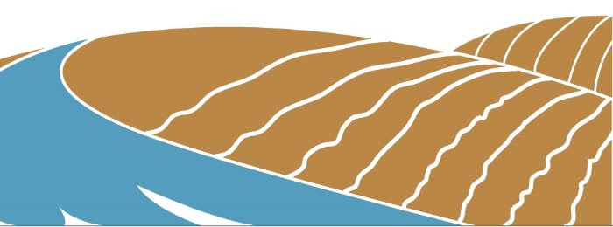
Free and virtually open to the public. Click here to watch. Enjoy!
To see other interesting TREAD Talks, click here.
Char Miller
Char Miller is the W. M. Keck Professor of Environmental Analysis and History at Pomona College, and formerly on the faculty at Trinity University, in its History and Urban Studies programs. He is the author of such books as San Antonio: A Tricentennial History (2018), On the Edge: Water, Immigration, and Politics in the Southwest (2013), Deep in the Heart of San Antonio: Land and Life in South Texas (2004), and San Antonio: An Environmental History (2005). Forthcoming in 2021 is Westside Rising: How San Antonio’s 1921 Flood Destroyed a City and Sparked a Latino Environmental Justice Movement. Miller served on San Antonio’s Open Space Advisory Committee and Tree Preservation Ordinance Committee and worked closely with the Witte Museum’s many exhibits about land and water in South Texas.

