The Texas Hill Country Exchange (TXHCX): A Proposal
By Jim Blackburn

Executive Summary:
The Trinity Edwards Springs Protection Association (TESPA) is proposing to join with the Greater Edwards Aquifer Alliance (GEAA) to develop the Texas Hill Country Exchange (TXHCX). TXHCX is a system that will use funds donated by those wanting to offset their carbon footprint to pay landowners for owning, restoring and maintaining ecological systems. Similarly, those wanting to protect spring and river flows and endangered species will have a similar opportunity.
This "nature based solution” is modeled after the Texas Coastal Exchange (https://www.texascoastalexchange.org/) that has been developing a carbon dioxide removal and storage system on the Texas coast since 2018.

The benefits of this strategy include:
  - Protects springs, groundwater, aquifer recharge and endangered species
  - Strengthens erosion control and leads to improved water quality
  - Provides a significant boost to rural economies
  - Creates a new revenue stream for rural landowners both small and large
  - Completely voluntary, requires no tax or regulation
  - Is open to the public at an affordable price point
  - Can be framed as Texans funding Texas conservation
  - A positive step towards addressing climate change in the Hill Country

The Proposal:
The Trinity Edwards Springs Protection Association (TESPA) is proposing to join with the Greater Edwards Aquifer Alliance (GEAA) to develop the Texas Hill Country Exchange (TXHCX). TXHCX is a system that will pay landowners for owning, restoring and maintaining ecological systems that contribute to societal goals such as carbon dioxide removal from the atmosphere, protection of stream flows, springs and groundwater and protection of endangered species. This system is based on the Texas Coastal Exchange (https://www.texascoastalexchange.org/) that has been developing a carbon dioxide removal and storage system on the Texas coast for the last two years.
The basic concept is that landowners who possess lands that provide these ecological services would receive “grants” from TXHCX to protect important ecological features within the Hill Country landscape. These “grants” would be funded by contributions from donors who might wish to store their carbon footprint, protect springs and aquifers and/or habitat of endangered species. In exchange for these grants, the landowners would agree to leave the land or groundwater undisturbed for a period of ten years.
There are many decisions that need to be made going forward. First, there is a question as to what are the boundaries of the Hill Country for purposes of TXHCX? In Figure 1, a proposed boundary is included that goes one county east of the Balcones escarpment in order to include some of the excellent black land prairie soils found in these counties which provide a contrast to the more rocky conditions within the Hill Country per se. Additionally, the boundary goes one county south of San Antonio to insure the inclusion of the metropolitan areas in the exchange boundaries.
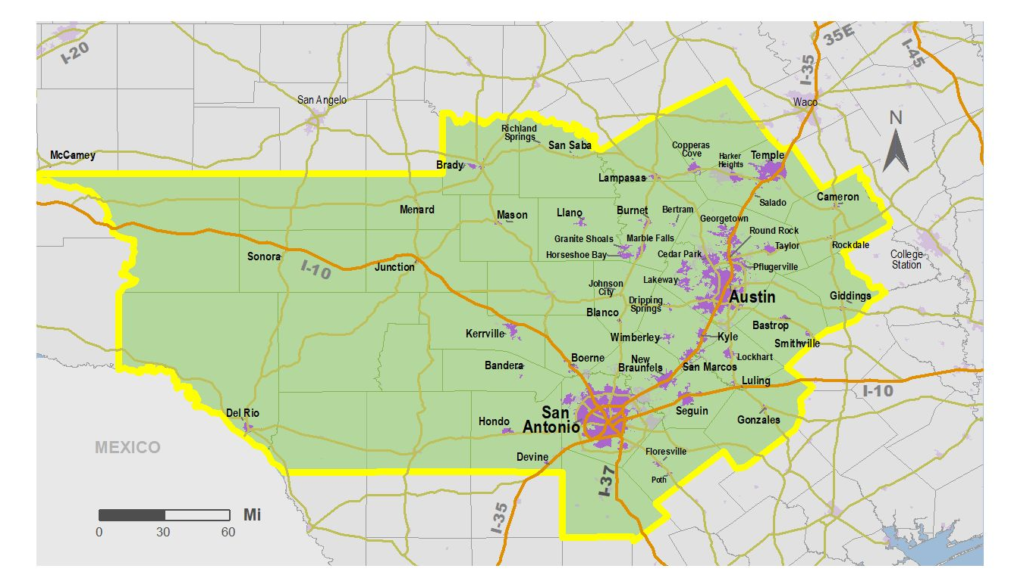

Figure 1. Potential boundaries of Texas Hill Country Exchange
From an ecological service standpoint, there are several types of ecological services that are worthy of preservation. The first of these is carbon sequestration. Photosynthesis removes carbon dioxide from the atmosphere and stores it in the wood of trees and the roots and soil surrounding grassland plants. Sequestration is provided by both the oak/juniper forest complex within the Hill Country, the hardwood forests along riparian corridors and in the blackland prairie soils east of IH-35. These three systems have the potential to provide at least one ton of carbon storage per acre per year, and literature values indicate that some may yield more than that amount. Much work remains to be done to determine the potential yield and the geographic boundaries of these various ecosystems. Figure 2 gives an approximate location of these various systems in a descriptive manner. Much more detailed ecological information will be required to pin down the characteristics of these various systems.
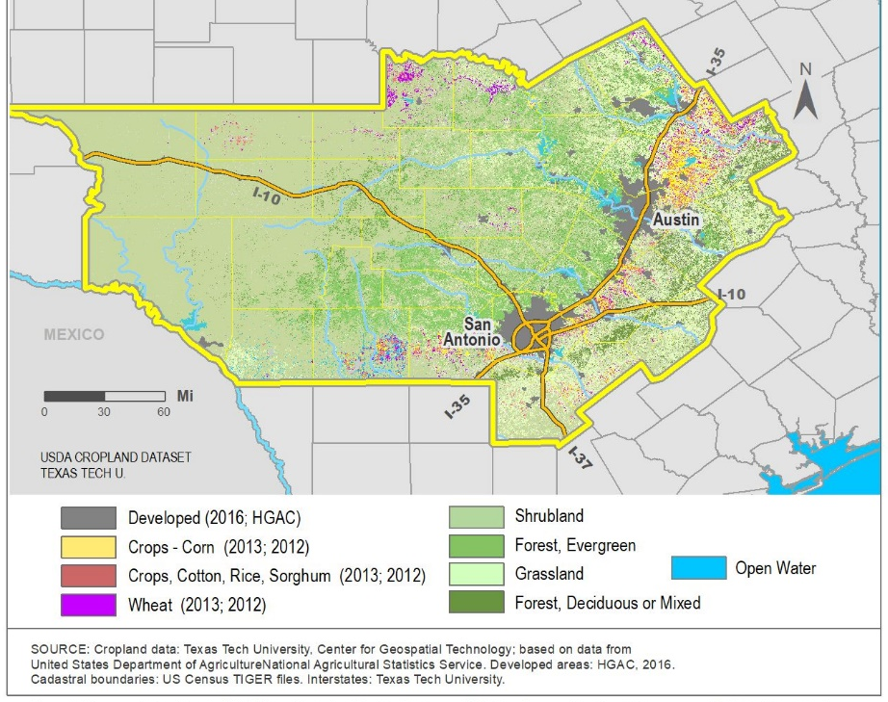
Figure 2. Cropland data identifying both forested areas and grasslands and croplands. Source: Texas Tech University, Center for Geospatial Technology.
In addition to carbon sequestration, there is the water-related ecological service, quantity and quality. A primary concern is spring flows within watersheds. Springs are the lifeblood of the Texas Hill Country. They are a major source of flow in the key rivers throughout the Hill Country, including the Guadalupe, the San Antonio, the Nueces, the Llano, the Pedernales, the Sabinal and the Blanco. If the springs are lost, so is much of the flow especially during the critical summer period – flow needed for recreation, endangered species, and downstream water supply. It is just wrong that Texas law has not linked groundwater protection to surface water availability, but it has not. By creating a monetary value for protection of springs TXHCX can create a means of protection currently lacking.
The proposed action relative to springs is straightforward. Landowners surrounding major springs would be paid to not develop their groundwater – to leave it in place, to leave it in the ground to supply the springs year-round. Under Texas law, the landowner owns his/her groundwater as a property right, and we propose to work with this concept of private property. In this manner, value will accrue to good stewards who protect the springs. The same could be done regarding aquifer recharge areas, although the initial priority would be to protect land adjacent to springs such as Jacob’s Well in Wimberley. There are also some interesting legal issues that such payments would raise, such as creation of value for in situ groundwater that is NOT intended to be developed which could be important in the creation of arguments regarding a potential “taking” of property by the actions of groundwater districts in issuing permits that have negative impacts on the groundwater surrounding springs. A map of the springs of the Texas Hill Country is shown in Figure 3 and a map of the various watersheds of the Hill Country is shown in Figure 4.
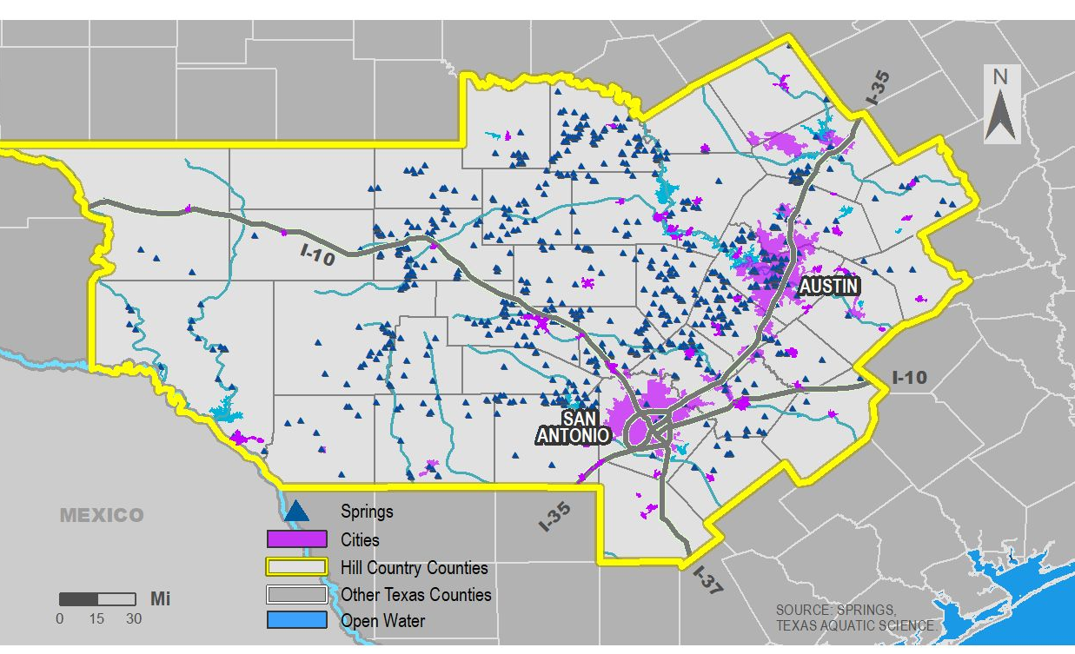

Figure 3. Texas Hill Country springs.
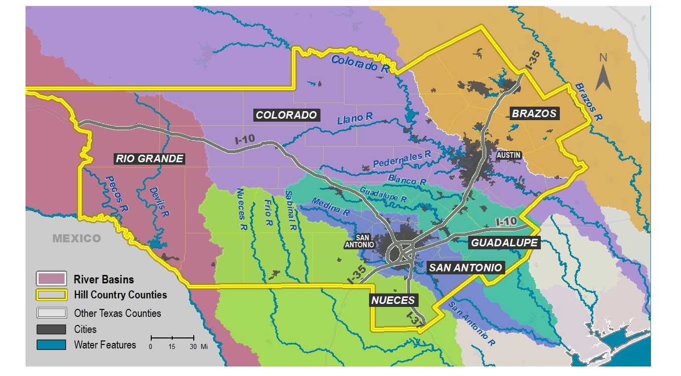
A third area of interest is the protection of habitat of endangered species. There are many endangered species in the Texas Hill Country, birds (Golden cheeked warblers, black-capped vireos), endangered mussels, salamanders and invertabrates . Each of these species can be found in certain areas. Each of the geographic areas can be managed to protect these species. This may or may not be integrated with a Habitat Conservation Plan that might allow those potentially impacting the habitat and/or water to receive protection in the form of a Section 10 permit that would allow an incidental take of the species. Such a plan is currently under development by the Guadalupe Blanco River Authority (GBRA). There is much to be developed here, but the bottom line is that these ecological systems provide habitat for endangered species that has dollar value to certain interests, and such value can be mediated in an exchange. The breeding area for the Golden-cheeked warbler is shown in Figure 5. The area where the Texas Fatmucket mussel is found is shown in Figure 6.

Figure 4. Watersheds arising within and/or draining the Texas Hill Country.
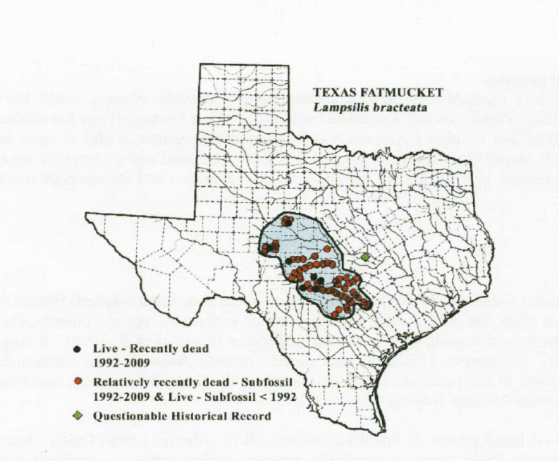
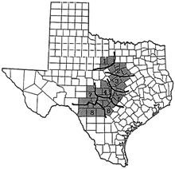

Figure 5. Breeding area of golden-cheeked warbler Figure 6. Texas Fatmucket mussel use area.
The bottom line is that there is great potential to establish an ecosystem exchange in the Texas Hill Country that can help us reach our conservation goals of protection of the land and water resources of the Texas Hill Country. In this regard, there are some key questions for those of you with interests in the Texas Hill Country.
- Are you and/or your group interested in seeing this Texas Hill Country Exchange established?
- Are you and/or your group interested in being a part of a stakeholder group to help establish this process for the Texas Hill Country?
- Would you be willing to participate in a Zoom conversation to get this effort underway?
- Would you be willing to help us raise money to make this happen?

