OPINION//COMMENTARY

Commentary: City has tools to protect the aquifer. Use them.
Jim Smyle, For the Express-News
Aug. 12, 2022Updated: Aug. 14, 2022 10:44 a.m.
Comments
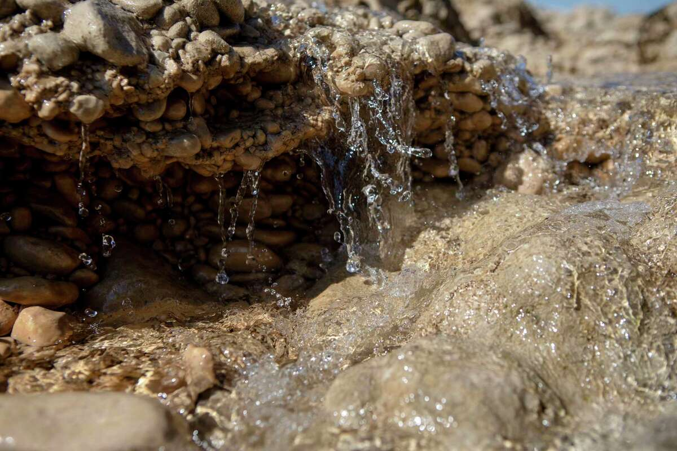
Water pours over limestone rocks and into the Edwards Aquifer. The city has existing tools to protect our primary source of drinking water, but does it have the political will?
Josie Norris, The San Antonio Express-News / Staff Photographer
Re: “A vanishing way of life? Growth in N.W. Bexar leads to concerns about environment and water,” Front Page, July 10:
It was disappointing and frustrating to read that Mayor Ron Nirenberg said the city “has very little tools to manage the growth in those sensitive areas and in the county” and that our best hopes for protecting the quality of our irreplaceable, primary source of drinking water, the Edwards Aquifer, lies in the SA Tomorrow Comprehensive Plan, which “is key to balancing development and environmental concerns.”
I must disagree.
First, a search for “Edwards Aquifer” on the SA Tomorrow website reveals no mention of it.
Yes, the unique challenge of “balancing development and environmental concerns” to protect our primary supply of drinking water warrants no mention in our current sustainability agenda.
Even if it did, one would have to forgive a skeptical resident for noting that such documents routinely lack any follow-through in the form of policies that City Council adopts, providing direction to the city manager and relevant city departments to develop the strategies needed to incorporate these policies into their day-to-day decision-making and activities.
From a public policy viewpoint, our current system is so dysfunctional that, as the article states, “Many advocates for a healthy environment believe neither the city nor state regulations go far enough, and some are trying to get San Antonio officials to amend the UDC this year to incorporate stricter rules.”
This is the tail trying to wag the dog. Unified Development Codes exist to implement policy, not make it.
So, what can be done? The article provides some hints:
• San Antonio Water System President and CEO Robert Puente has said the utility will follow the city’s lead. He has repeatedly stated that SAWS needs policy guidance from the city because, as SAWS trustee Amy Hardberger reminds us, “If you build it, they will come.” Nirenberg should develop a task force to create such guidance.
• Existing restrictions are not “an obstacle for long,” as the article states. Developers routinely receive changes to limits and restrictions — with City Council’s approval. The only thing stopping us from protecting the recharge zone and sensitive areas in the contributing zone — lands eligible for city-purchased conservation easements — is a lack of clear policy direction.
Such direction might provide that within these sensitive areas the city will not entertain requests for waivers for up-zoning; negotiate reductions in impact fees; permit activities that modify natural drainage within the 100-year flood plains or clear existing stream-side vegetation; or amend planning documents meant to define compatible development.
This would not stop all incompatible development, but it would give the city some moral authority to stop or address such development.
In September 2020 I co-authored a commentary with Nirenberg. In it we wrote the Edwards Aquifer Protection Program “must be viewed as one tool within a needed, longer-term and more comprehensive strategy to protect this irreplaceable resource.” We called for broad strategies and policies to achieve this; as well as for concerned citizens to hold future mayoral and council candidates accountable.
We have tools to protect the aquifer. Let’s use them.
Jim Smyle, a Greater Edwards Aquifer Alliance board member, is an independent consultant with experience in technical, policy and public investment aspects of natural resources and watershed management.

