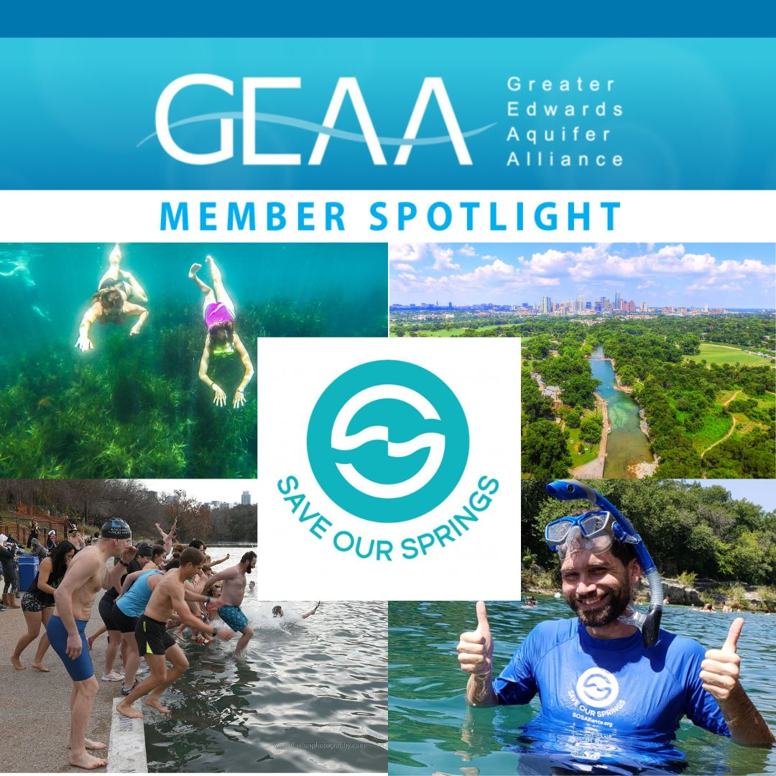

Today we’re giving a special shout-out to one of our founding member groups who joined together to create GEAA nearly 20 years ago!
The Save Our Springs Alliance came to life in 1990 as a loose coalition of citizens fighting a massive 4,000 acre development proposal for the Barton Creek watershed. After an all-night meeting with Austin city council, the Barton Creek PUD was rejected and a movement began to strengthen the 1986 Comprehensive Watersheds ordinance under the acronym SOS: “Save our Springs”.
Their educational program bartonspringsuniversity.org serves to educate central Texans about our local ecosystem and how to preserve the Edwards Aquifer and Barton Springs through cool activities like snorkeling eco-tours, kid camps, outdoor experiential learning, and fun at Barton Springs Pool. More on their education and outreach efforts, legal advocacy services, and their 30+ years as Austin’s Water Watchdog is at sosalliance.org.

5/12/23

