
Tay Floyd: Project Manager and GIS Analyst
Tyler Heck: GIS Analyst and WebMap designer
Haley Busse: GIS and Data Analyst
TABLE OF CONTENTS
ABSTRACT……………….…………………...……………………………………………...3
1. INTRODUCTION AND PROBLEM STATEMENT……………….…………………...…3
2. DATA…………………………………………………………….…………………..

3. METHODS…………………………………………………….…………………….

4. RESULTS & DISCUSSION……………………...………….…………………….

5. CONCLUSIONS…………………………………………………………………….

6. REFERENCES………………………………………………..…………………….
6.1 Appendix I: Group Members Contributions…………………………………..……
6.2 Appendix II: Metadata……………………………………………………………...
6.3 Appendix III: Additional Contacts and Resources for Information Collection……………………………………………………………………………….

Abstract
At the request of the Greater Edwards Aquifer Alliance (GEAA) the Water Wizards consulting group has completed several different tasks. First, we have completed a new weighted overlay analysis that has been updated with relevant data provided by the Texas Commission of Environmental Quality (TCEQ). This weighted overlay analysis focuses on Wastewater Treatment Plants (WWTPs) that are in our study area with varying levels of importance being assigned to each plant based on their proximity to an impaired water source, and which priority zone they operate in. Secondly, we have created an interactive web map and dashboard for the GEAA that will allow them to track the effluent data of each WWTP that operates within the region of the Edwards Aquifer and its nearby surrounding area. Lastly, we are providing the GEAA and Texas State University with this written report which will provide an in-depth explanation of the goal of our project, the obstacles we faced during our study, our data sources, methodology, and our results. We believe that providing these deliverables will further enable the GEAA to maintain water purity levels within the Edwards Aquifer.
1. Introduction and Problem Statement
For this project, our scope was the Edwards Aquifer with additional emphasis of interest being placed on the ten counties that surround it, and each wastewater treatment plant that releases effluent discharge into a waterway that connects to the aquifer. The Edwards Aquifer is an impressively vast geological phenomenon that is made up of an abundance of karst limestone chambers, holes, and caves. Its unique permeable structure allows it to rapidly fill with various types of water, whether that be from the natural flows of the rivers of Central Texas, the rainfall from the clouds above, or from effluent discharge released by local wastewater treatment plants.
The formation of the Edwards Aquifer occurred ages ago and has historically been the primary source of fresh drinking water for the people that inhabited Central Texas in the past. This has remained constant, and the aquifer continues to provide drinking water to the people of San Antonio and the neighboring cities of New Braunfels, Austin, etc. as well as plays a part in supporting local industries such as tourism and agriculture. However, certain things have drastically changed as time has passed and there are new variables that need to be considered and accounted for. Due to dramatic rises in human population and the overall urban expansion of Central Texas, the Edwards Aquifer has become increasingly vulnerable to being corrupted by outside pollutants. As such, the Greater Edwards Aquifer Alliance has taken notice and deemed the aquifer to be at risk of contamination.
Residential and commercial developments along the recharge zone of the aquifer are increasing due to the population increase which means a higher likelihood of pollutants within the aquifer. One way of reducing the pollutants making their way into the aquifer is making sure that all areas of public and government land being used are taken into account when designing the most productive outcome for sewage treatment. A study on sanitary sewage systems and water supply from a city in Brazil in 2022 showed that areas situated peripherally from the most focused areas had the highest risk of leakage. This information may be relevant to the information we have found during the course of this project.
In response to this increased vulnerability, the GEAA has begun to crack down on local WWTPs over the last few years and has placed greater emphasis on tracking their operational practices. This emphasis has been placed with the intention of tracking data and identifying which WWTPs have effluent discharge rates that are within compliance or are in violation. That is where the Water Wizards consulting group came in. Our part in all of this has been to aid GEAA in their endeavor to accomplish this goal, and we believe we have succeeded in doing so. By taking the data provided by TCEQ we have created a reliable interactive web map application that allows a user to sift through different WWTPs and analyze data seamlessly. In addition, we have run a weighted overlay analysis within ArcGIS Pro that identified which WWTPs are most likely to discharge contaminated wastewater into waterways that feed into the Edwards Aquifer.
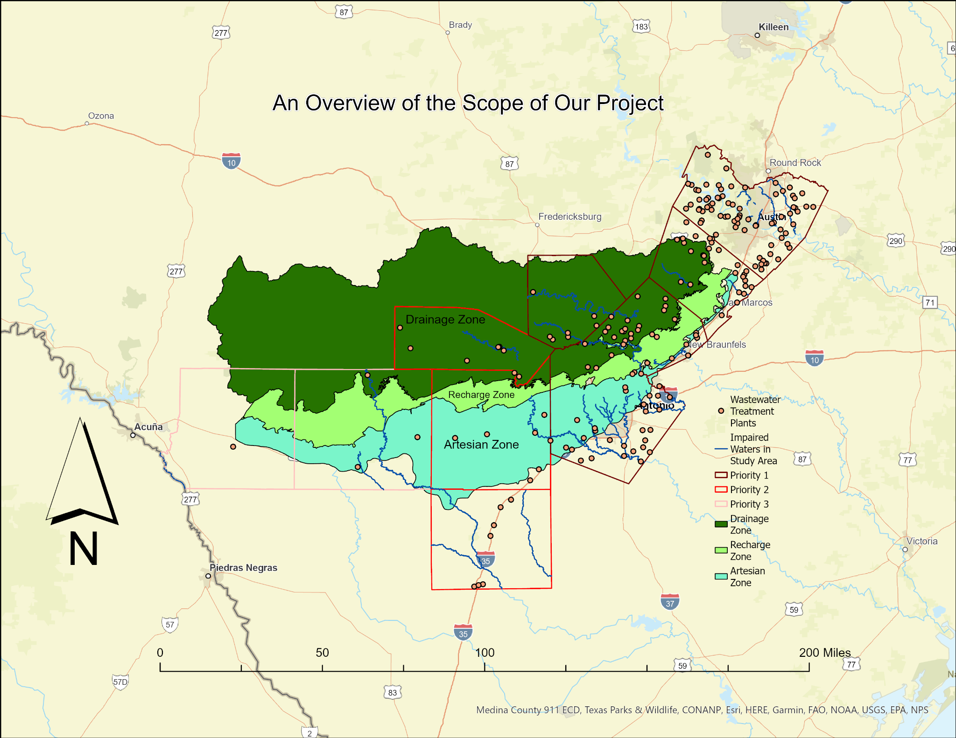
Figure 1. Scope
2. Data
2.1 Data
- Start and permit renewal date of TPDES and TLAP permits
- Address / Description of location
- Volume of Treatment
- Method of Treatment
- Phosphorus and Nitrogen discharges permitted
- Discharge rate
- Carbonaceous biological oxygen demand
- Total suspended solids
- Ammonia nitrogen
- Past violations (if any)
- Beneficial Reuse (if any)
- Additional Conditions of Permit (if any)
- County maps, shapefiles, and quantitative data, which depict locations and vulnerability rankings for wastewater lines
- Edwards Aquifer Zones and Regulatory Boundary
- Surface water shapefiles
- Surface water quality criteria, such as TCEQ/EPA stream impairment status
- Available wastewater spills data
The completion of the project relies on the data that we acquire to complete the vulnerability assessment and create a visualization of our findings. All necessary data has been provided to us and cleaned by our group before using. Most of the data we use comes from TCEQ, the state’s regulatory body for the safe management of waste. A public information request was submitted to TCEQ by a previous group working to complete this project and the data was not given to that group in time to complete the project fully. TCEQ has now provided the data in time for Water Wizards GIS Consulting to complete this project for GEAA. This data includes the address and coordinates of the wastewater treatment plants, notices of enforcement (NOE), notices of violation (NOV), and discharge rate. All of this data gathered from TCEQ was used during the analysis for finding the vulnerability level of each wastewater treatment plant within the study area.
The data used for this project was thoroughly cleaned by our group and more data has been added since the first meeting with our client. Multiple fields of information including effluent discharge rate, carbonaceous biological oxygen demand, total suspended solids, ammonia nitrogen, total phosphorus, and annual total nitrogen have been added to our list of information that shows when a wastewater treatment plant is selected on our web map. The full list of information for each wastewater treatment plant shows when a plant is selected on our web map that includes, address and coordinates of the plant, RN number, water quality number, number of NOVs and NOEs, site name, county, and all of the data that was added as stated previously.
The remaining shapefiles needed to complete this project were acquired through an open-source ArcGIS server through ArcGIS Pro as well as TCEQ’s open data portal. These files include county maps, Edwards Aquifer zones, waterways, and impaired waterways. All of this data was provided in a vector format that needed to be converted to a raster format in order to run the weighted analysis. Further details about how we will use all of the data as stated within the methodology section of this proposal.
3. Methodology
After having received all the necessary data to complete this project we were able to begin our work without being held back by waiting for various companies to respond to information requests. The first task was assessing the data provided and cleaning it. Since our project is focused on WWTP data from within the seven counties provided, we were able to remove data that lies outside of them which cleans the data a great deal. After the data had been cleaned, only information from the focused counties remained for the next steps in our process.
While cleaning the data will undoubtedly be the most tedious task on our list, there are multiple other steps that went into creating a final product as laid out in the flow chart we created below (Fig. 1). Our group will be providing a weighted vulnerability analysis that identifies the wastewater treatment plants with the potential to cause the most harm to the aquifer. This was done with a weighted overlay that took into account several factors of importance. The components of this weighted analysis were the location within the aquifer zones, and proximity to waterways and impaired waterways. Wastewater treatment plants with many violations and a high output pose the greatest risk to the Edwards Aquifer, particularly those in close proximity to impaired waterways that feed into the aquifer.
In order to complete the weighted overlay analysis we needed to complete several tasks that would allow us to run the tool. The first thing we did was add all of the data we would be using to a new map project including the counties of interest shapefiles, the aquifer zone shapefiles, waterway and impaired waterway shapefiles, and points where all of the wastewater treatment plants are located. Once all of this data was added to a new map we clipped the waterway shapefiles to only display waterways that flow within the counties of interest. We then added buffers to the waterways and impaired waterways. We created four buffers for unimpaired waterways depicting a 1 mile, 0.75 mile, 0.5 mile, and 0.25 mile buffer with the smaller buffers being most at risk. A buffer for impaired waterways was given a 0.25 mile buffer with an even higher risk than the unimpaired waterways.
The next step to performing the weighted overlay analysis consisted of converting all of the vector shapefiles into a raster format since the weighted overlay tool will only analyze raster datasets. After they had all been converted we could then move on to running the weighted overlay tool. Once all of the raster datasets that would be used in the weighted overlay were added they needed to be assigned weights that depict higher to lower risks for the wastewater treatment plants. We ran into trouble while performing this task due to the capacity of all of the datasets. This should provide GEAA with an accurately ordered list of the plants they should be allocating resources towards monitoring and holding accountable moving forward.
Once the analysis was completed, the data was used to create an interactive web map that the GEAA will be able to use and share with the public. This map displays the locations of each WWTP in the Edwards Aquifer recharge zone along with relevant information pertaining to each location, as well as identify the facilities we deem most at risk of harming the aquifer. Users of the web map will be able to query specific locations by name, location, or attribute to learn more information about the wastewater treatment plants they are interested in. These tools will allow GEAA and citizens to have a clear understanding of the spread and impact of wastewater treatment plants in their communities.
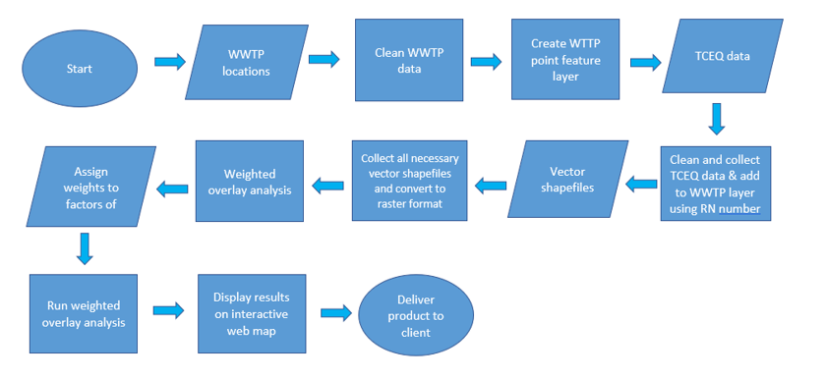
Figure 2. Flow chart
4. Results and Discussion
-Present findings in a logical order using figures/tables
After having completed our weighted analysis we were able to produce results displaying the most at risk wastewater treatment plants to the least at risk wastewater treatment plants. This ranking was based on multiple factors including location within the aquifer zones, and proximity to waterways and impaired waterways. Displaying this data with four colors representing the most to least at risk treatment plants for contaminating the aquifer, a visual of possible trends can be located as seen in Figure 3 below.
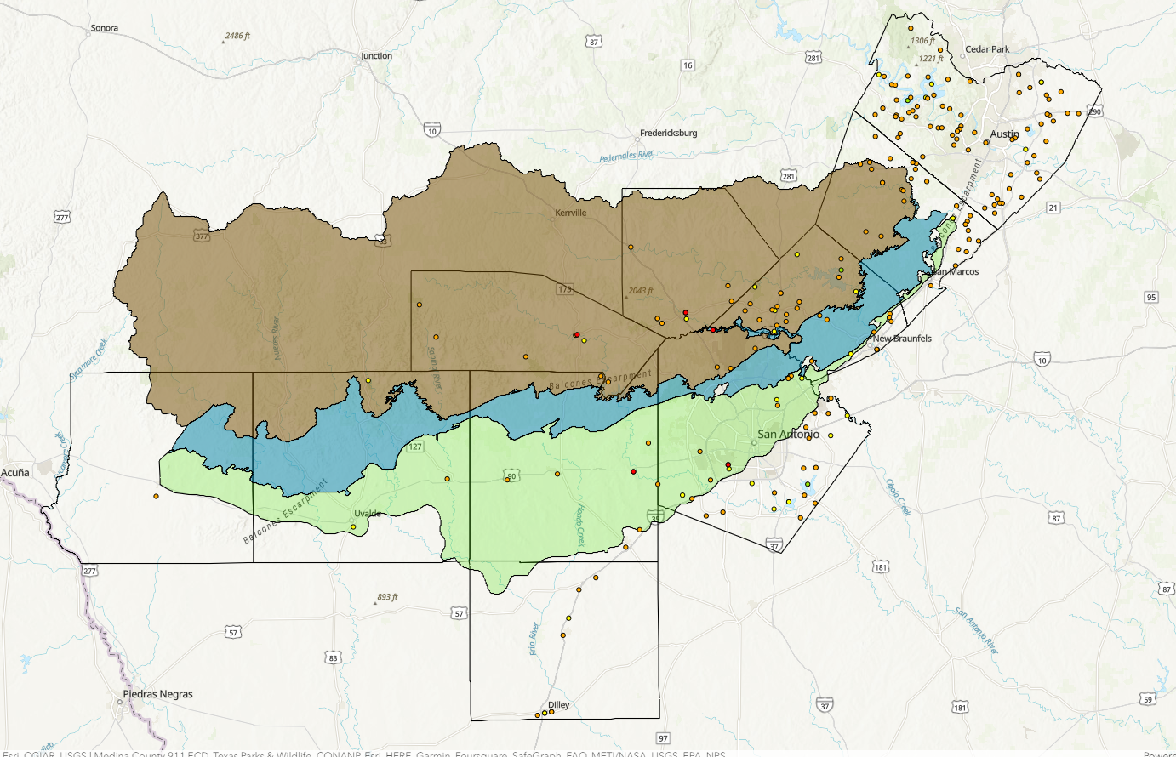
Figure 3. Final map result
Having this map to view will help our client to better understand what trends if any can be located before looking at the other possible factors that may contribute to the wastewater treatment plants contamination of the aquifer.. With this data being displayed on an interactive web map our clients and the public will be able to get a better understanding of where these plants tend to be located as well as be able to open up and look at all of the attributes that may be contributing to the possible risk. These factors include address and coordinates of the plant, RN number, water quality number, number of NOVs and NOEs, site name, county, effluent discharge rate, carbonaceous biological oxygen demand, total suspended solids, ammonia nitrogen, total phosphorus, and annual total nitrogen. With this full list of information being provided for each plant, a plan will be much easier to execute in terms of prevention.
The most important issues raised by the results of our project is the fact that over 83% of all wastewater treatment plants within the study area are within 0.25 miles of a waterway and there are no wastewater treatment plants further than 0.75 miles from a waterway (Fig. 4). This is concerning due to the fact that these treatment plants are possibly posing the risk of contamination of the aquifer. It is also important to note that out of the three aquifer zones, the zone containing the most wastewater treatment plants is the drainage zone many of them located very near the recharge zone (Fig. 5) This is beneficial for our client to know in order to focus more closely on those treatment plants so that the contamination from pollutants to the aquifer is limited. Another important fact to note from our findings is that most wastewater treatment plants are not located within any aquifer zone but still within a short distance to a waterway. Once a wastewater treatment point is clicked on the map, a pop-up window will be displayed listing all of the plant's information which will give our clients a more clear understanding of whether or not a specific wastewater treatment plant needs to be prioritized over others due to its other characteristics (Figure 6.).
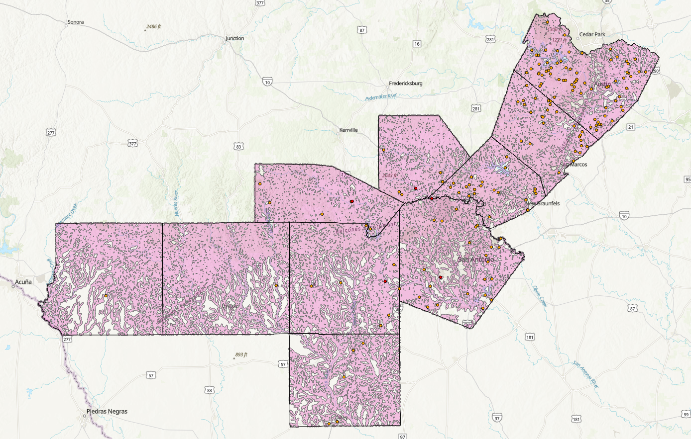
Figure 4. 0.25 mile river buffer
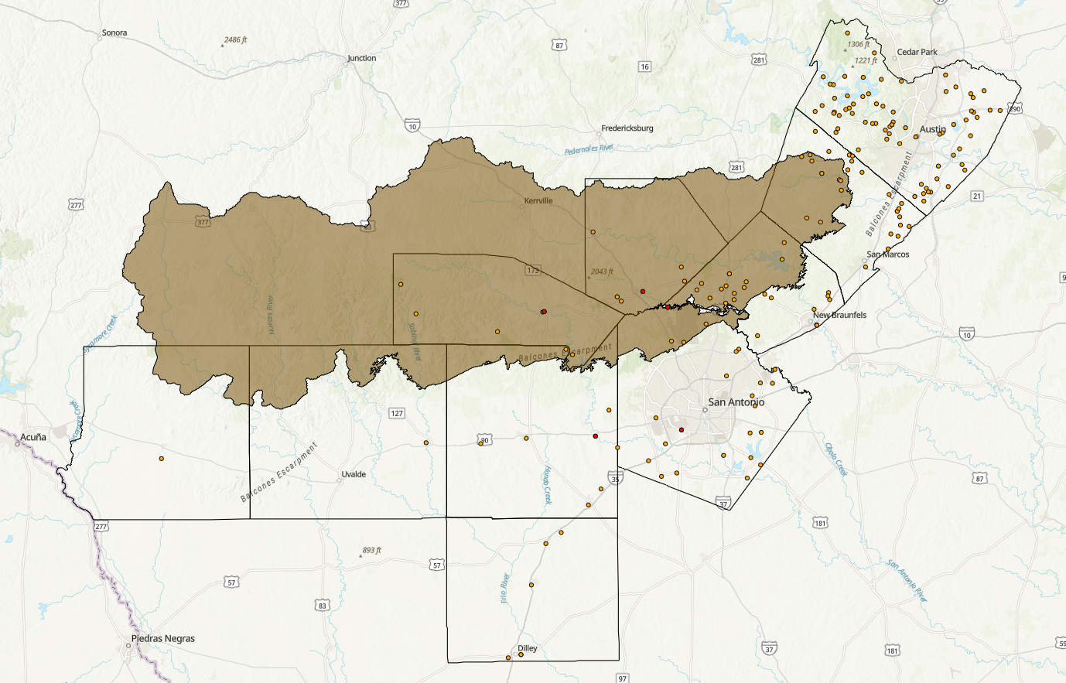
Figure 5. Drainage zone of the Edwards Aquifer
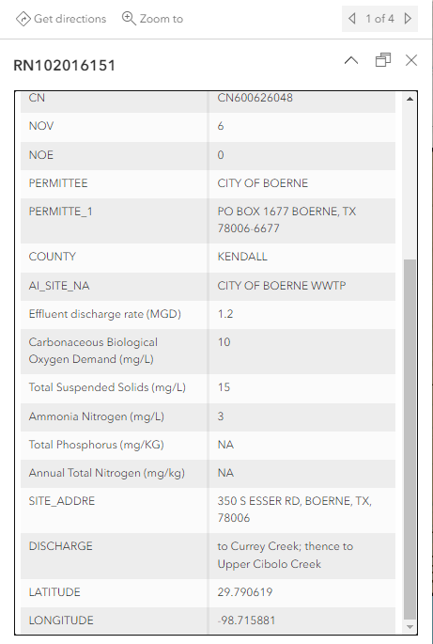
Figure 6. Pop-up list of site attributes
Throughout this project we did encounter issues along the way which need to be noted in order for our client or others who work with this data in the hopes that it may help prevent issues in the future. The first problem we encountered was having to narrow down the list of treatment plants that were located outside the area of interest. We then needed to go through and check the location of each wastewater treatment plant individually and re-enter a more accurate location and coordinates for the plants. This task was time-consuming and tedious although necessary for being able to produce a reliable and accurate map displaying the data. The next issue we encountered was having to go through the tables of NOEs and NOVs and create new fields within the master list of all of the wastewater data displaying how many notices of violation and notices of enforcement each of the facilities was given. In order to do this our group needed to search the RN number of each individual facility and record how many NOVs and NOEs each of them had acquired. Our last and most concerning problems arose during the final steps of the project that included the tedious rasterization of all of the vector data we had acquired. The rasters needed to be the same cell size and correct projection in order for the weighted analysis to run. When we ran the weighted analysis ArcPro crashed multiple times and we needed to work with Dr. Yuan as well as Raihan in order to solve the issues. Luckily Raihan was able to find the issue and lead us in the right direction and we were able to provide a finished project for GEAA.
If we were able to do this project over again with ample time and resources it may be beneficial to take into account how other areas have gone about solving this same problem. An experiment conducted in 2018 in east Ukraine aimed to locate the problem areas of the sewage infrastructure. The experiment conducted showed a strong link between the condition of the water infrastructure and the occurrence of disorderly artificial recharge in urban areas. Knowing how other places have conducted research similarly to ours is important for future projects in the sense that it may provide other avenues and direction to how this project is completed. This project was successful in finding out where the most at risk wastewater treatment plants are located as well as providing ample information for each site. Using GIS to get a better understanding of where these plants are located was essential and it leads our client to have a better understanding of what actions need to be taken in order to mitigate and reduce the higher risk plants.
5. Conclusion
The final product of our project was a success. Water Wizards GIS Consulting were able to deliver a fully interactive map to the GEAA with the required data attached to the waster water treatment plant point data. A suggestion to further this project, is incorporating different census populations projections to conduct and additional analysis to include population where determining risk.
6. References
“2020 Census Geography.” Capitol Data Portal, Texas Legislative Council, 1 Sept. 2021, https://data.capitol.texas.gov/dataset/2020-census-geography.
Silva, Marcelo Carlos de Oliveira, et al. “Risk Mapping of Water Supply and Sanitary Sewage Systems in a City in the Brazilian Semi-Arid Region Using GIS-MCDA.” MDPI, Multidisciplinary Digital Publishing Institute, 15 Oct. 2022, https://www.mdpi.com/2073-4441/14/20/3251.
TNRIS DataHub, https://data.tnris.org/.
Vystavna, Y., et al. “Quantification of Water and Sewage Leakages from Urban Infrastructure into a Shallow Aquifer in East Ukraine - Environmental Earth Sciences.” SpringerLink, Springer Berlin Heidelberg, 15 Nov. 2018, https://link.springer.com/article/10.1007/s12665-018-7936-y.
6.1 Appendix I:
Tay Floyd:
- Data Cleaning (adding and deleting data within Excel to create WWTP point data)
- Writing and Editing: Helped write and edit the final power point (Conclusion and Appendix)
- Created all final raster files in Final Deleverable
  - All Raster Files and Weighted Overlay files
- Created the Final Deleverables files
Haley Busse:
- Data Cleaning (adding and deleting data within Excel to create WWTP point data)
- Writing and Editing: Helped write and edit the final power point (Data, Methodology, and Final Results)
- Created the Buffer Layers
Typler Heck:
- Data Cleaning (adding and deleting data within Excel to create WWTP point data)
- Created Final Poster
- Writing and Editing: Helped write and edit the final power point (Intro, Purpose, and Summary)
- Created all Map Layers
6.2 Appendix II: Metadata

File Name | Description
Map Layers.xml | Metadata file containing the different map layers
Rasterized Buffers.xml | Metadata file containing the rasters created using the river buffers
Rasterized Study Area.xml | Metadata file containing the rasterized files for the aquifer zone in the study area
Reclassified Rasters Layers.xml | Metadata file with the reclassified rasters for the weighted overlay
River Buffers.xml | Metadata file containing river buffers for the streams within the study area
Weighted Overlay.xml | Metadata file containing the weighted overlay analysis

6.3 Appendix III: Additional Contacts and Resources for Information Collection
Link to TCEQ Public Information Request and email to send request:
https://www.tceq.texas.gov/downloads/agency/data/records-services/orr-request.pdf
openrecs@tceq.texas.gov
Additional TCEQ Contacts:
Tara Gilbert: Tara.gilbert@tceq.texas.gov
DFW Region | Small Business and Local Government Assistance
Office: 817-588-5927 | Teleworking: 682-231-3358
Marie Boren: marie.boren@tceq.texas.gov
Program Support and Environmental Assistance Division
Office of Compliance and Enforcement
Data line phone number: 512-239-3282
TCEQ Central File Room Records Online Service and TCEQ data browse:
https://www.tceq.texas.gov/agency/data/records-services
https://data.texas.gov/browse?Dataset-Category_Agency=Texas+Commission+on+Environmental+Quality&q=TCEQ&sortBy=relevance

