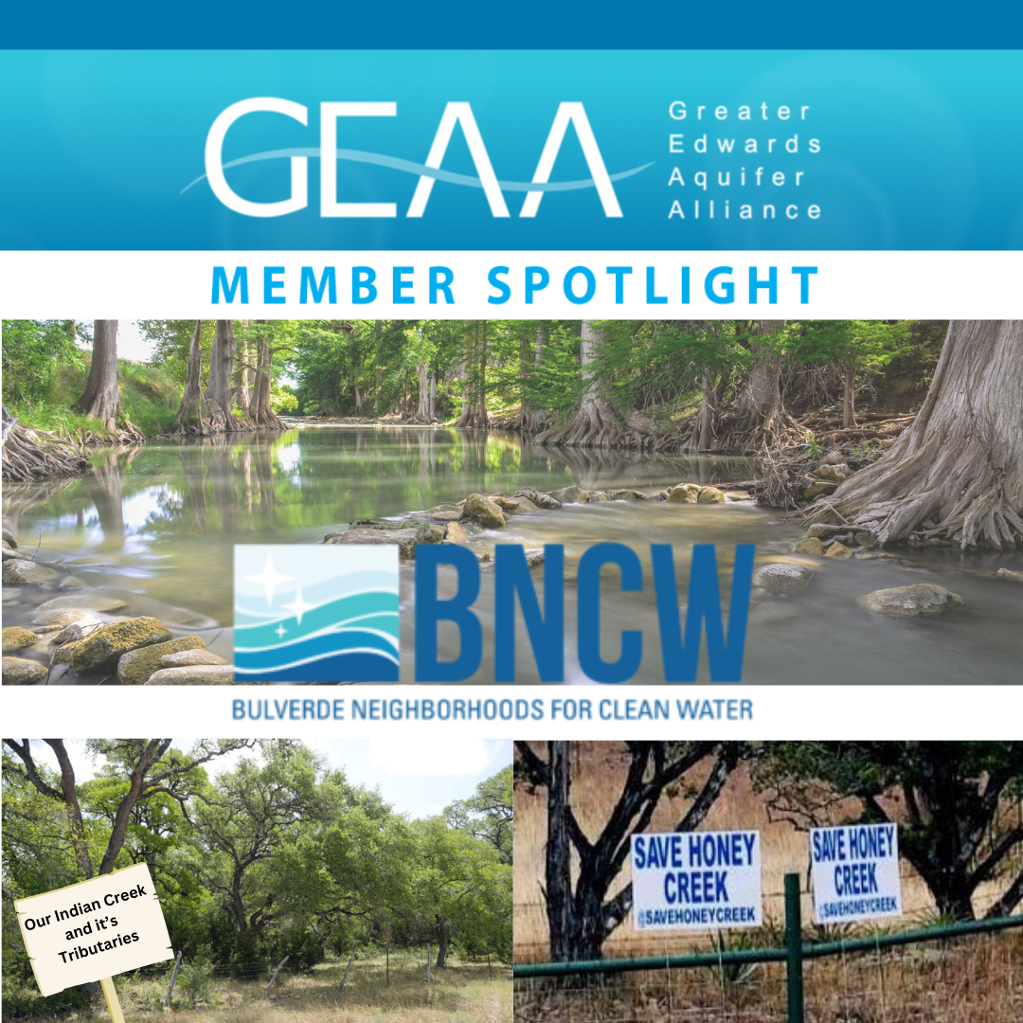

GEAA is thankful to our member group
Bulverde Neighbors for Clean Water.
We appreciate their commitment to keeping our community safe, and clean, and ensuring that the native beauty that makes Bulverde and surrounding areas endure for future generations.
The purpose of Bulverde Neighborhoods for Clean Water (BNCW) is to protect public health, the environment, and the quality of life for residents in Bulverde and Comal County with special emphasis on water quality in the Cibolo Creek watershed. With this purpose as the focus, BNCW represents its members by participating in the decision-making process of local, state, and federal officials on issues related to pollution and protection of natural resources.
BNCW has been a steadfast partner in advocacy for sustainable and rational development in the fast growing Bulverde area. Learn more about their efforts here.

