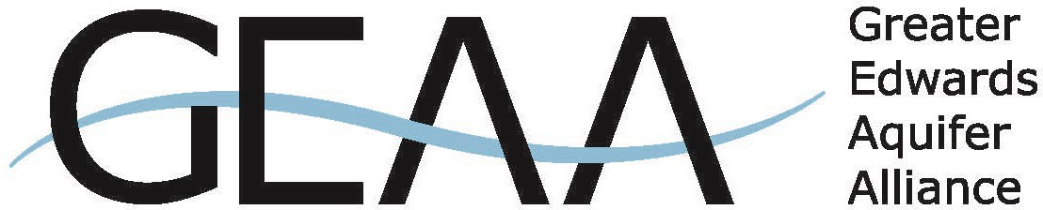
Estimated Fair Market Value: $ Min. Bid Amt: $

Detailed Description of Donation
Donation Deadline: Oct. 9, 2026
SILENT AUCTION DONATION FORM
Support the 2026 Legends of the Past – Water for the Future Gala
The Greater Edwards Aquifer Alliance (GEAA) invites you to support our 2026 Legends of the Past –
Water for the Future Gala by donating an item, experience, or service to our silent auction.
Join us as we celebrate water, history, and San Antonio's legendary past on the banks of Salado Creek. This spirited evening of remembrance and revelry will raise critical funds to protect the Edwards and Trinity aquifers—the lifeblood of Central Texas—and preserve the springs, rivers, streams, and natural landscapes that depend on them.
Thank you for considering a silent auction donation. Your generosity helps ensure that the waters, wildlife, and wild places of the Texas Hill Country remain protected for generations to come.
Donor Signature Date
For questions or concerns: mailto:kellie@aquiferalliance.org
The Greater Edwards Aquifer Alliance is a non-profit 501(c)(3) organization.
(Tax ID#: 25-1907558) Donations are tax deductible to the fullest extent allowed by law.
This letter is your receipt, please retain for your records.
Please return this form one of two ways:
Email: kellie@aquiferalliance.org (subject line: auction)

Mail: GEAA- PO Box 15618 San Antonio, Tx 78212
DONATION INFORMATION (please print)

THANK YOU.
DONATION PICK UP INFORMATION

- I will deliver
- Please contact me to arrange pickup
DONOR INFORMATION (please print)
Name of Donor:

Business Name (if applicable):

Contact Name:

Mailing Address, State, Zip:

Phone: Email:

