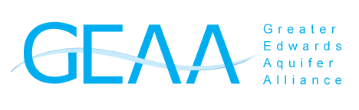
Maximize the Impact of your gift to the Greater Edwards Aquifer Alliance!
Gift of Stock
Donating long-term highly appreciated securities can provide you with significant tax benefits. When transferring stock directly to GEAA, you can claim an income tax deduction and avoid capital gains tax.
IRA Charitable Rollover
If you are over the age of 70½, you can make a Qualified Charitable Distribution (QCD) from your Individual Retirement Account up to $100,000. A donation transferred directly from your IRA to a qualified charity like GEAA generally reduces your taxable income by 100% of the amount you transfer. When you turn 72, a QCD will count towards your Required Minimum Distribution (RMD). Note: In 2020, the CARES Act waived the requirement for minimum distributions.
Donor-Advised Fund (DAF)
A Donor-Advised Fund (DAF) is a type of charitable investment account that provides an immediate tax benefit to you and allows you to recommend grants to charities of your choice over time. An increasingly popular charitable vehicle, DAF’s are an excellent way to both simplify your charitable giving and facilitate your strategic philanthropic goals. Please contact your financial advisor or GEAA Executive Director Annalisa Peace at annalisa@aquiferalliance.org for more information.
For assistance, contact Annalisa Peace at annalisa@aquiferalliance.org
or (210)320-6294.
Thank you for your interest and continued support towards GEAA’s mission to promote effective broad-based advocacy for protection and preservation of the Edwards and Trinity aquifers, their springs, watersheds, and the
Texas Hill Country that sustains them.
The Greater Edwards Aquifer Alliance is a non-profit 501(c)(3) organization. (Tax ID#: 25-1907558) Donations are tax deductible to the fullest extent of the law.

